PROOF OF USABILITY

# User context

You've find this App on the play-store, The app page was the following:

Perm'App Culture, the brand new app that's will help you to begin in permaculture! Find information about theory made by the greatest name of this domain and learn the practical side with tutorials from professionals! Manage your garden for having a virtual assistant which remind you some important events of your plant’s life

For each question you will be free to say what you think about the App or image show to you.

Ok ! Let’s Start the Test !

First Step : Opening

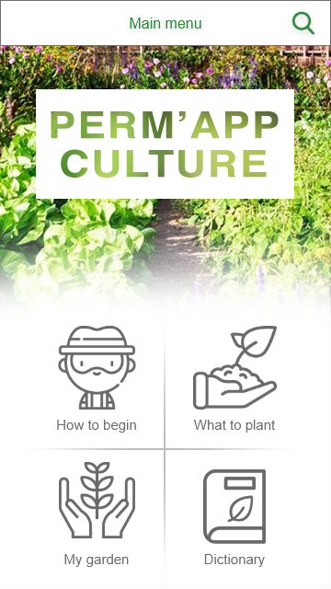

Q1. Which section will you go first naturally after opening the app ?

Write your answer here . . .

Q2. Intuitively this menu, in order to transmit information to the users is:

* Too rich
* Well balance
* Too poor

Change the color of the answer

Q3. Describe what you type of information you attend to find behind :

|  |  |
| --- | --- |
| “How to begin” section ? | “What to plant” section ? |
| Write your answer here . . . | Write your answer here . . . |
| My garden | Dictionary |
| Write your answer here . . . | Write your answer here . . . |

# Action to do : *Find information about StrawBerry Plant*

**Before interacting**

Q4. To wich section you will go?

|  |  |  |  |
| --- | --- | --- | --- |
| How to begin? | What to plant? | My garden | Dictionary |

Change the color of the answer

↓GO NEXT PAGE ↓

*For each menu choose an answer:*

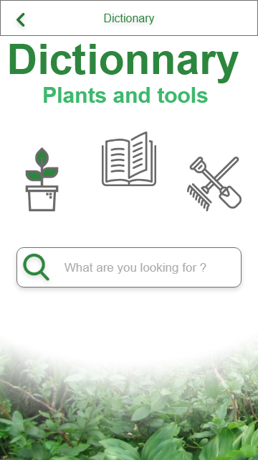

Q7. How many interaction do you think there is in this menu ? Write your answer here . . .

Q8. Intuitively this menu, in order to transmit information to the users is:

* Too rich
* Well balance
* Too poor

Change the color of the answer

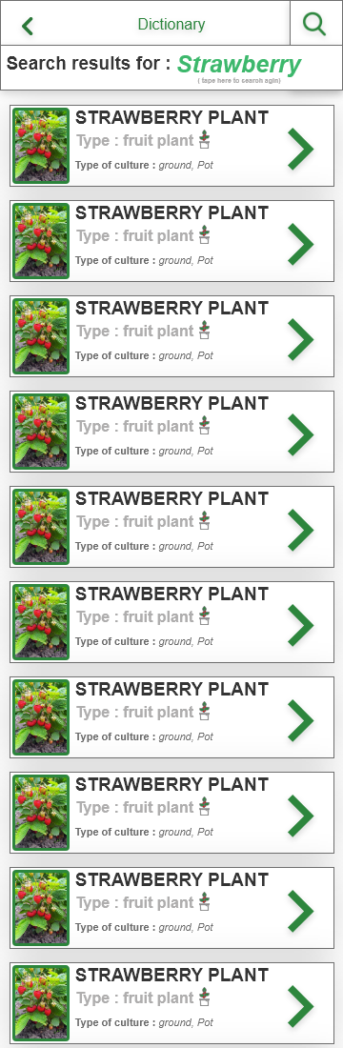

Q9. How many interaction do you think there is in this menu ? Write your answer here . . .

Q10. Intuitively this menu, in order to transmit information to the users is:

* Too rich
* Well balance
* Too poor

Change the color of the answer

Q9. How many interaction do you think there is in this menu? Write your answer here . . .

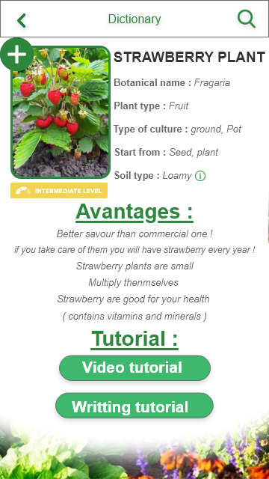

Q10. This page give the information you want?

|  |  |  |
| --- | --- | --- |
| Not at all | Yes | Too many |

Change the color of the answer

**After interacting**

Q5. Did you have any difficulties to find the information?

|  |  |  |
| --- | --- | --- |
| Yes many | Just a little | No one |

Change the color of the answer

Q6. If you had some difficulties can you describe the reason(s):

|  |  |
| --- | --- |
| Element of the ui not readable | Navigation system bad designing |

Change the color of the answer

# Action to do : *Find an article about the permaculture story!*

**Before interacting**

Q4. To wich section you will go?

|  |  |  |  |
| --- | --- | --- | --- |
| How to begin? | What to plant? | My garden | Dictionary |

Change the color of the answer

↓GO NEXT PAGE ↓

*For each menu choose an answer:*

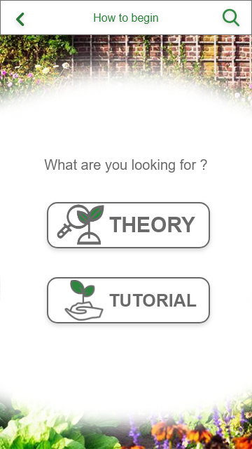Q9. How many interaction do you think there is in this menu? Write your answer here . .

Q10. This page give the information you want?

|  |  |
| --- | --- |
| No | Yes |

Change the color of the answer

Q11. What type of information is behind “Theory” ?

Write your answer here . .

Q. 12 What type of information is behind

“Tutorial” ?

Write your answer here . .

Q13. How many interaction do you think there is in this menu? Write your answer here . .

Q14. The navigation system of this menu is :

|  |  |
| --- | --- |
| Bad | Good |

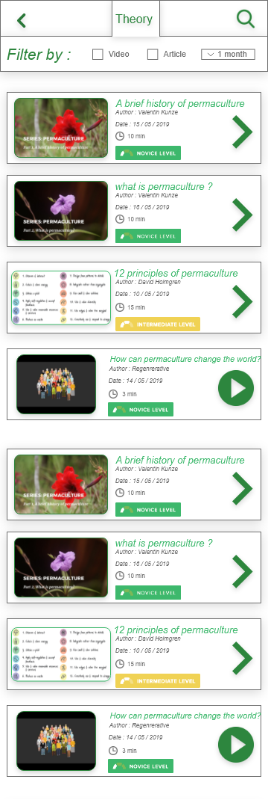

Q15 : For you this menu give you sufficient information about the article ?

|  |  |
| --- | --- |
| Yes | No |

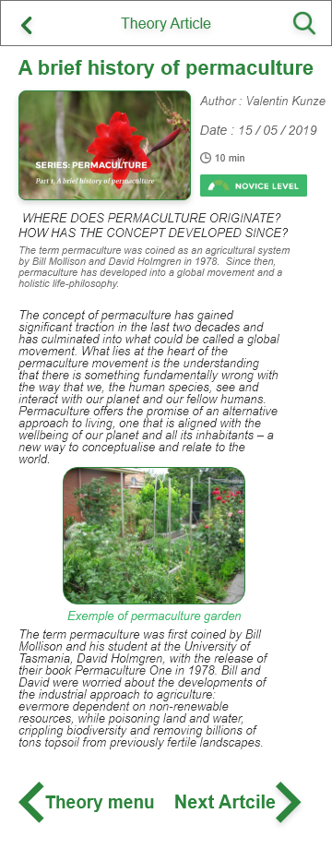

Q16. The design of this page is helpful for the lecture ?

|  |  |
| --- | --- |
| Yes | No |

Change the color of the answer

Q17. Have you any difficulties to read ?

|  |  |
| --- | --- |
| Yes | No |

Change the color of the answer

Q17.b. If you have some difficulty what type it is ?

|  |  |  |
| --- | --- | --- |
| Bad contrast to read | To small | Disorganized |

Change the color of the answer

**After interacting**

Q18. Did you have any difficulties to find the information?

|  |  |  |
| --- | --- | --- |
| Yes many | Just a little | No one |

Change the color of the answer

Q19. If you had some difficulties can you describe the reason(s):

|  |  |
| --- | --- |
| Element of the ui not readable | Navigation system bad designing |

Change the color of the answer

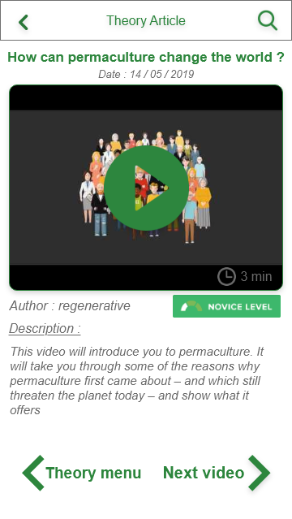

Q20. The design of this page is helpful for the lecture ?

|  |  |
| --- | --- |
| Yes | No |

Change the color of the answer

Q21. Have you any difficulties to find how to start the video ?

|  |  |
| --- | --- |
| Yes | No |

Change the color of the answer

Q21.b. If you have some difficulty what type it is ?

|  |  |
| --- | --- |
| Not intuitive | Disorganized |

Change the color of the answer

# Action to do : *Add a Strawberry plant in my garden section!*

**Before Interacting with this menu :**

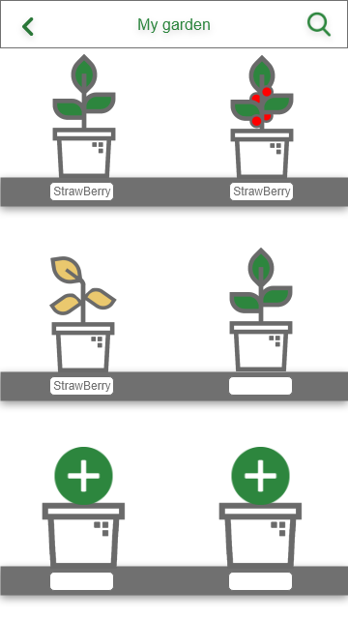Q22. How many interaction do you think there is in this menu? Write your answer here . .

Q23. This page give the information you want?

|  |  |
| --- | --- |
| No | Yes |

Change the color of the answer

Q24. Can you tell us what is the different status of the plant ? ( 1 or 2 words )

Green one: Write your answer here .

Orange one: Write your answer here .

↓GO NEXT PAGE ↓

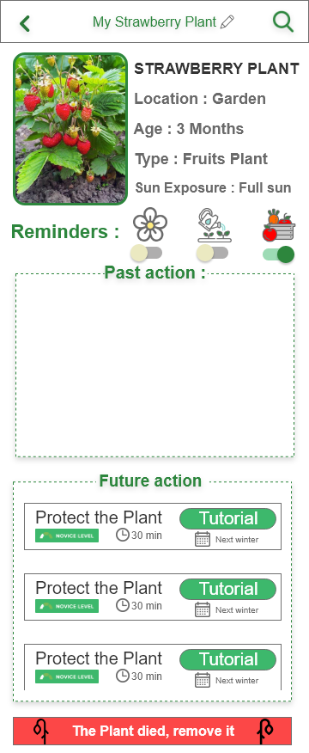Q25. The design of this page is helpful for the lecture ?

|  |  |
| --- | --- |
| Yes | No |

Change the color of the answer

Q26. For you what function has the reminders?

|  |  |
| --- | --- |
| Blue One | Write your answer here . |
| Orange One | Write your answer here . |
| Purple One | Write your answer here . |

Q27. The design of the future action is?

|  |  |
| --- | --- |
| good | Bad |

Change the color of the answer